* **SYMMETRIC MATRIX**
* To understand if a matrix is a symmetric matrix, it is very important to know about transpose of a matrix and how to find it. If we interchange rows and columns of an m × n matrix to get an n × m   matrix, the new matrix is called the transpose of the given matrix. There are two possibilities for the number of rows (m) and columns (n) of a given matrix:
* If m = n, the matrix is square
* If m ≠ n, the matrix is rectangular

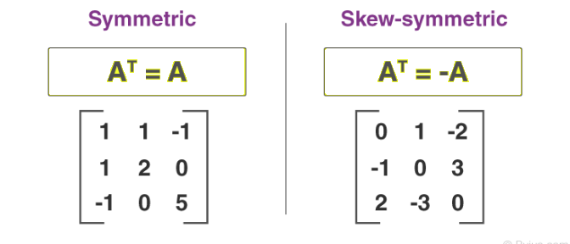

* For the second case, the [transpose of matrix](https://byjus.com/maths/transpose-of-a-matrix/)can never be equal to it. This is because, for equality, the order of the matrices should be the same. Hence, the only case where the transpose of a matrix can be equal to it, is when the matrix is square. But this is only the first condition. Even if the matrix is square, its transpose may or may not be equal to it. For example:



* Let us take another example.

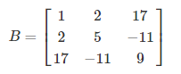

* If we take the transpose of this matrix, we will get:

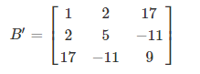

* We see that B = B’. Whenever this happens for any matrix, that is whenever transpose of a matrix is equal to it, the matrix is known as a **symmetric matrix**. But how can we find whether a matrix is symmetric or not without finding its transpose? We know that:
* If A = [aij]mxn then A’ = [aij]nxm ( for all the values of i and j ) So, if for a matrix A,aij = aij (for all the values of i and j) and m = n, then its transpose is equal to itself. A symmetric matrix will hence always be square.
* Some examples of symmetric matrices are:

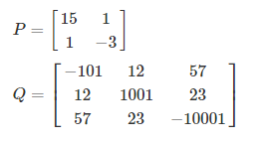

**Properties of Symmetric Matrix**

* Addition and difference of two symmetric matrices results in symmetric matrix.
* If A and B are two symmetric matrices and they follow the commutative property, i.e. AB =BA, then the product of A and B is symmetric.
* If matrix A is symmetric then An is also symmetric, where n is an integer.
* If A is a symmetric matrix then A-1 is also symmetric.